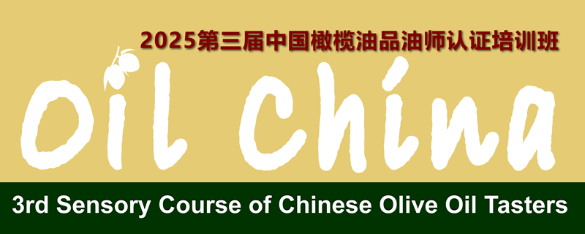

**3rd Sensory Course of Chinese Olive Oil Tasters**

Sponsor Application Form

|  |  |  |  |  |  |
| --- | --- | --- | --- | --- | --- |
| Our company agrees to sponsor 2025 3rd sensory course of Chinese olive oil tasters and accepts the related regulation of this course. | | | | | |
| Company Name： |  | | | Contact: |  |
| Tele： |  | Website： |  | | |
| E-mail： |  | | | | |
| Address： |  | | | | |
| **Sponsor Opportunity** | ( ) **As the Exclusive Sponsor: Euro 35000 / USD 37000**  ( ) **As the Sponsor: Euro 3000 / USD 3200 per 1 company**  (please tick✔) | | | | |
| **Company Brief** (300 words or the attachment)**：** | | | | | |

**Date: Stamp or Sign:**

Note: please fill in this form and then send it to：[info@eoliveoil.com](mailto:info@eoliveoil.com) / [regalland@163.com](mailto:regalland@163.com)